Tanaya Mukund Bhide

2020BTECS00011

BATCH T5

SOFTWARE ENGINEERING TOOLS LAB

ASSIGNMENT NO 1

(Module 1- Introduction to FOSS)

**1. Differentiate between free software, Open source software, and proprietary software concerning its properties.**

Free software: Free software, also known as freeware, is software that users can use without any cost. This software is usually distributed for free, and users can modify and redistribute the software as per their needs. Users can also access the source code and make changes to it. Examples of free software are Linux, Ubuntu, and Apache OpenOffice.

Open-source software: Open-source software is a type of software that allows users to access its source code and modify it as per their needs. Users can freely distribute the software and use it without any cost. However, users may need to comply with specific licenses for the software. The primary objective of open-source software is to provide a platform for collaborative development, where users can work together to improve the software. Examples of open-source software are Mozilla Firefox, LibreOffice, and WordPress.

Proprietary software: Proprietary software is software that is owned by a company or an individual, and its source code is not available to the public. Users need to pay to use the software and cannot modify or distribute it without the owner's permission. Proprietary software may have more features and advanced functionalities than free or open-source software. Examples of proprietary software are Microsoft Office, Adobe Photoshop, and AutoCAD.

| Properties | Free Software | Open Source Software | Proprietary Software |
| --- | --- | --- | --- |
| Licensing | The software is free to use, modify, and distribute | The source code is available for viewing and modification but may have certain usage restrictions | The software is owned and licensed by a single company or individual |
| Source Code | The source code is available to view, modify, and distribute | The source code is available to view and modify, but may have certain usage restrictions | The source code is not available for viewing or modification |
| Distribution | The software can be distributed freely | The software can be distributed freely, with certain restrictions depending on the license | Distribution rights are controlled by the owner of the software |
| Collaboration | Collaboration and contributions from the community are encouraged and welcomed | Collaboration and contributions from the community are encouraged and welcomed | Collaboration and contributions are limited to those who have been granted permission by the owner |
| Customizability | The software can be modified and customized to meet the user's specific needs | The software can be modified and customized to meet the user's specific needs but may have certain usage restrictions | The software cannot be modified or customized by the user |
| Support | Support is provided by the community or the original developers | Support is provided by the community or the original developers | Support is provided by the owner of the software |
| Cost | The software is available at no cost | The software is available at no cost but may have certain usage restrictions | The software may require payment or a subscription fee |
| Examples | Linux, Apache, MySQL, Firefox | Mozilla Firefox, OpenOffice, Android | Microsoft Windows, Adobe Photoshop, Microsoft Office |

**2. Enlist some examples along with the purpose and properties (at least 10) of FOSS and proprietary software concerning the database.**

FOSS SOFTWARES

1. MYSQL

Purpose: MySQL is a popular open-source relational database management system that is widely used in web applications and software development. It is designed to handle large databases and is often used as a backend database for websites and applications.

Properties:

Scalability: MySQL is highly scalable and can handle large amounts of data and users.

Security: MySQL provides several security features such as encryption, access control, and password protection to secure data.

High performance: MySQL is optimized for performance and can handle thousands of transactions per second.

Flexibility: MySQL supports a wide range of programming languages, platforms, and operating systems, making it highly flexible.

Open-source: MySQL is free to use and distribute under the GNU General Public License (GPL).

Community-driven: MySQL has a large and active community of developers and users who contribute to its development and support.

2. PostgreSQL is a free and open-source relational database management system.

Purpose: PostgreSQL is designed to handle workloads ranging from small single-machine applications to large internet-facing applications with many concurrent users. It is used as a primary data store or as a data warehouse, used for transactional processing or analytical processing, and used in web, mobile, desktop applications, and enterprise software.

Properties:

License: PostgreSQL is released under the PostgreSQL License, a permissive open-source license.

ACID compliance: PostgreSQL is ACID (Atomicity, Consistency, Isolation, Durability) compliant, ensuring data consistency and integrity.

Extensibility: PostgreSQL allows users to extend the functionality by creating their data types, operators, and functions.

Scalability: PostgreSQL supports horizontal and vertical scaling, as well as clustering and replication.

Security: PostgreSQL has advanced security features, such as SSL support, role-based access control, and encryption support for data at rest and in transit.

Cross-platform: PostgreSQL is available for multiple operating systems, including Linux, Windows, macOS, and Unix.

3. MongoDB is a popular FOSS software that is designed for managing and storing document-oriented data. It is a NoSQL database program that stores data in JSON-like documents with flexible schema, making it ideal for managing unstructured data.

Purpose: MongoDB is designed to handle large volumes of data, provide high availability and scalability, and allow developers to build and deploy applications faster. It is often used for web applications, mobile apps, real-time analytics, and content management systems.

Properties:

MongoDB is a cross-platform database and runs on Windows, Linux, and macOS.

It supports a flexible data model that can handle data of any structure and type.

It provides high scalability and availability by supporting sharding and replication.

It offers powerful indexing and querying capabilities, including full-text search and geospatial search.

It has a robust security model, with support for role-based access control and encryption at rest and in transit.

It is built on a distributed architecture, making it easy to manage and scale across multiple machines or clusters.

4. Redis is an open-source, in-memory data structure store that is commonly used as a database, cache, and message broker. It is known for its high performance and ability to handle large amounts of data.

Purpose:

Caching and real-time analytics: Redis can be used as a caching layer to store frequently accessed data, which can greatly reduce the load on a database. Additionally, Redis can be used for real-time analytics, such as tracking website visitors or monitoring the performance of a mobile application.

Queuing: Redis provides features for implementing queues, which can be used to distribute workloads across multiple workers or processes.

Pub/sub messaging: Redis supports a publish/subscribe messaging model, which can be used for building real-time chat applications, notifications, or other messaging systems.

Properties:

In-memory storage: Redis stores all data in memory, which makes it extremely fast for read and write operations. However, this also means that Redis cannot store more data than the available memory.

No schema: Redis does not enforce a specific schema for stored data, which makes it flexible and easy to use for a wide range of applications.

Data persistence: Redis provides options for persisting data to disk, which can ensure data durability in case of failures or restarts.

5. MariaDB is a free and open-source relational database management system that is a community-driven fork of the MySQL relational database management system. It aims to maintain high compatibility with MySQL while providing additional features and performance improvements.

Purpose: MariaDB is used for managing and storing structured data for various applications, including web applications, e-commerce sites, and content management systems.

Properties:

MariaDB is licensed under the GNU General Public License.

It supports various operating systems, including Windows, Linux, and macOS.

MariaDB supports a wide range of programming languages, including C++, Java, Python, and PHP.

It has a modular architecture that enables users to add new storage engines, plugins, and features.

MariaDB is highly scalable and can handle large datasets.

It provides high availability and fault tolerance through features such as replication and clustering.

MariaDB supports advanced SQL features and provides a variety of built-in functions and operators.

**PROPRIETARY SOFTWARES**

1. Microsoft SQL Server

Microsoft SQL Server is a proprietary relational database management system (RDBMS) developed by Microsoft. It is widely used in enterprise applications for data storage and retrieval.

Purpose:

It provides a reliable, scalable, and high-performance database platform for critical business applications.

It supports business intelligence, data warehousing, and advanced analytics.

Properties:

It provides various features such as replication, clustering, and high availability for database redundancy and disaster recovery.

It offers advanced security features such as encryption, row-level security, and auditing.

It supports various programming languages and interfaces such as Transact-SQL, .NET, ODBC, JDBC, and OLE DB.

It offers enterprise-level management tools such as SQL Server Management Studio and SQL Server Configuration Manager.

It provides integration with other Microsoft products such as Visual Studio, SharePoint, and Excel.

2. Microsoft SQL Server is a proprietary relational database management system (RDBMS) developed by Microsoft. It is widely used in enterprise applications for data storage and retrieval.

Purpose:

It provides a reliable, scalable, and high-performance database platform for critical business applications.

It supports business intelligence, data warehousing, and advanced analytics.

Properties:

It provides various features such as replication, clustering, and high availability for database redundancy and disaster recovery.

It offers advanced security features such as encryption, row-level security, and auditing.

It supports various programming languages and interfaces such as Transact-SQL, .NET, ODBC, JDBC, and OLE DB.

It offers enterprise-level management tools such as SQL Server Management Studio and SQL Server Configuration Manager.

It provides integration with other Microsoft products such as Visual Studio, SharePoint, and Excel.

3. IBM DB2 is a relational database management system (RDBMS) that is designed to store, process, and manage large amounts of data efficiently. It is widely used in enterprise-level applications due to its scalability and reliability.

Some of the key features and properties of IBM DB2 are:

Multi-platform support: IBM DB2 is designed to work across a variety of platforms, including Windows, Linux, UNIX, and z/OS.

High performance: IBM DB2 is optimized for high-performance computing and can handle large datasets and complex queries.

Data compression: IBM DB2 provides built-in data compression capabilities that can reduce storage requirements and improve query performance.

Security: IBM DB2 includes advanced security features, such as authentication, authorization, and encryption, to protect sensitive data.

Backup and recovery: IBM DB2 includes robust backup and recovery capabilities that enable quick and efficient disaster recovery.

4. SAP HANA is a proprietary database management system that is designed for real-time analytics and data processing. It is an in-memory database system that can handle large volumes of data and can provide results in real time. It was initially released in 2010 and is developed by SAP SE.

Some of the properties of SAP HANA are:

In-memory database system: SAP HANA is an in-memory database system that can process large volumes of data in real time by storing data in memory rather than on disk.

High-performance computing: It provides high-performance computing with advanced analytics capabilities and supports various programming languages.

Columnar data storage: SAP HANA uses a columnar data storage format, which enables faster data retrieval and processing.

Parallel processing: It supports parallel processing that enables faster processing of large volumes of data.

Integrated platform: It is an integrated platform that can handle various data types and provides data integration and transformation capabilities.

5. Amazon Aurora is a proprietary relational database service offered by Amazon Web Services (AWS). It is designed to be compatible with MySQL and PostgreSQL databases and provides a high-performance, scalable, and highly available database solution for enterprise-level applications.

Purpose: Amazon Aurora is used for storing and retrieving data for web applications, e-commerce sites, and online gaming platforms. It is a cloud-native database that can handle large amounts of data and supports high read and writes workloads.

Properties:

High Performance: Amazon Aurora provides a high-performance database service with low latency and high throughput.

Scalability: It can scale up or down based on application requirements and provides up to 64 TB of database storage.

Availability: Aurora provides high availability by replicating data across multiple availability zones.

Security: It offers several security features such as encryption at rest and in transit, authentication and authorization mechanisms, and auditing tools.

Backup and Recovery: It provides automatic backups and point-in-time recovery for up to 35 days.

**3. Enlist some examples of free open-source exam software for online assessment.**

Here are some examples of free and open-source exam software for online assessment:

Moodle: Moodle is a popular open-source learning management system that provides a range of features for online assessment, including quizzes, assignments, and exams.

Open edX: Open edX is a free and open-source platform for creating and delivering online courses. It includes features for creating and managing exams and assessments.

TCExam: TCExam is an open-source computer-based assessment system that enables educators and trainers to author, schedule, deliver, and report on quizzes, tests, and exams.

Quizmaker: Quizmaker is an open-source online exam software that enables educators and trainers to create and administer tests, exams, and assessments.

iTest: iTest is an open-source software suite for creating and delivering online exams and assessments. It provides a range of features for test creation, scheduling, and grading.

GIFT format: The GIFT (General Import Format Technology) format is a free and open-source format for creating and sharing questions and assessments in various learning management systems and online exam software.

Safe Exam Browser: Safe Exam Browser is a free and open-source web browser that restricts access to other applications and system functions during online exams, providing a secure environment for online assessment.

Open Assessment Technologies: Open Assessment Technologies is an open-source software suite for creating and delivering online assessments. It provides a range of features for question creation, item banking, test authoring, and result analysis.

**4. Demonstrate any one exam software which is open source and freely available**

Moodle is a free and open-source learning management system (LMS) used by educators, trainers, and educational institutions to create and manage online courses and virtual learning environments. It was created by Martin Dougiamas in 2002 with a focus on providing educators with the tools to create engaging and interactive online learning experiences.

Moodle provides a platform for delivering a wide range of educational content, including multimedia resources, quizzes, assignments, forums, and chat rooms. It is highly customizable, allowing educators to design and organize courses to suit their specific needs, and it can be integrated with a range of other educational technologies, such as video conferencing and interactive whiteboards.

Moodle is used by millions of users worldwide, and it has a large community of developers who contribute to its ongoing development and improvement. Its popularity is due to its flexibility, ease of use, and ability to support a wide range of teaching and learning styles.

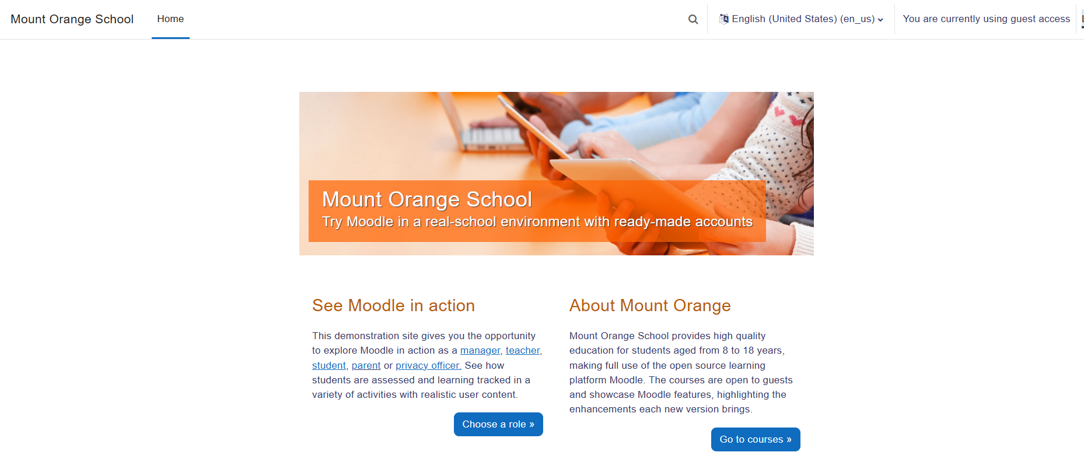 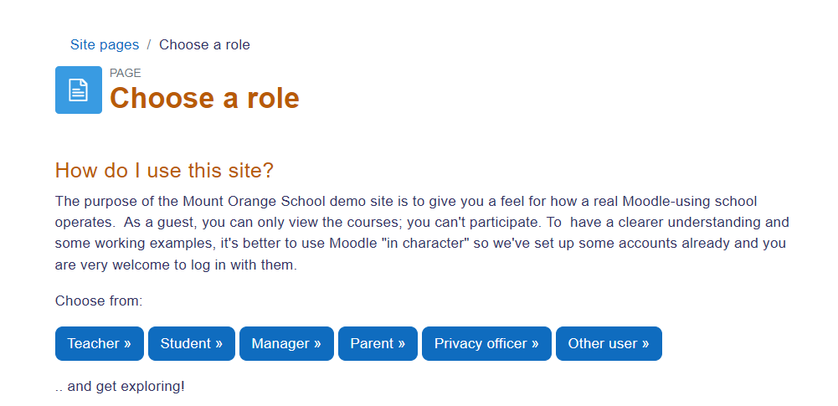

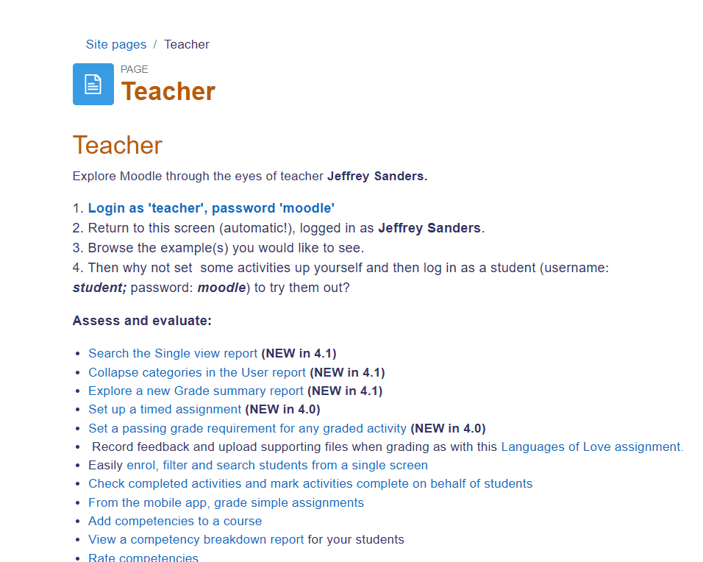

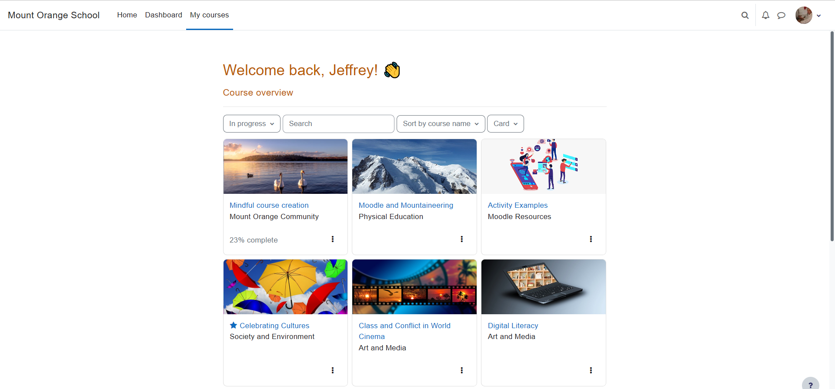

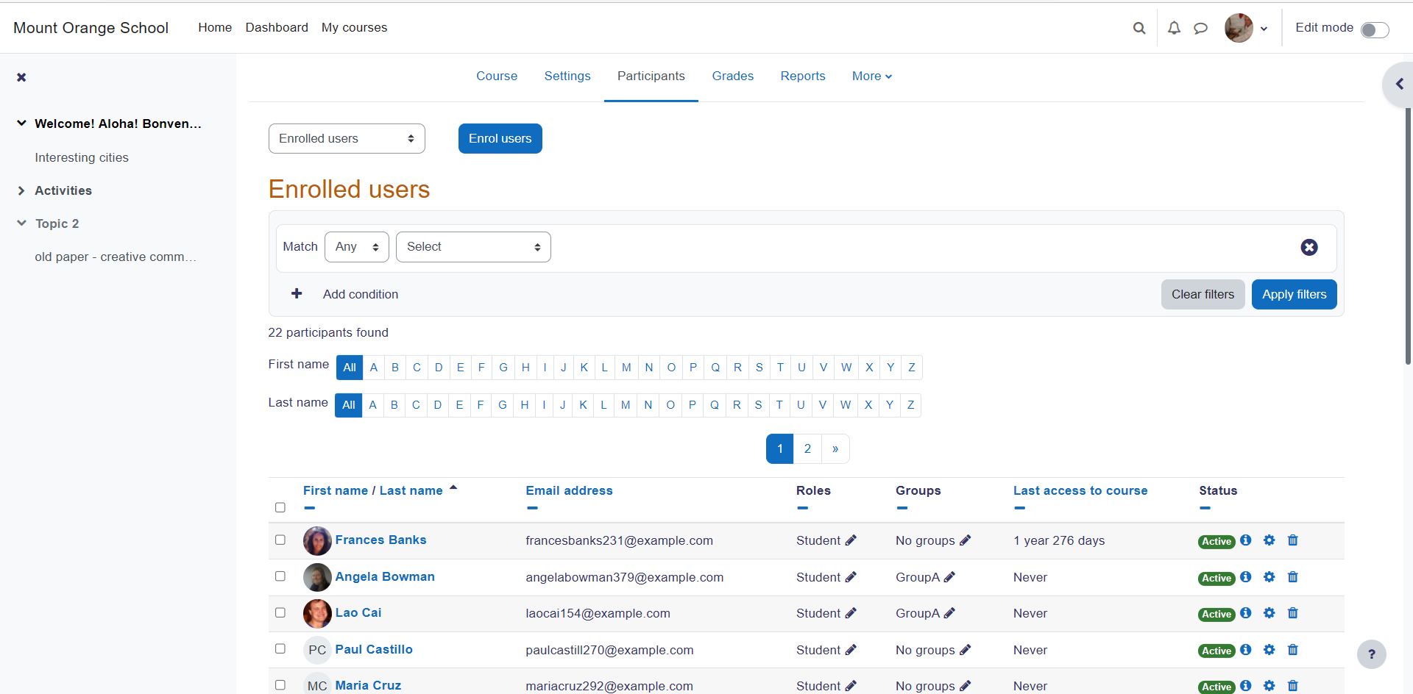

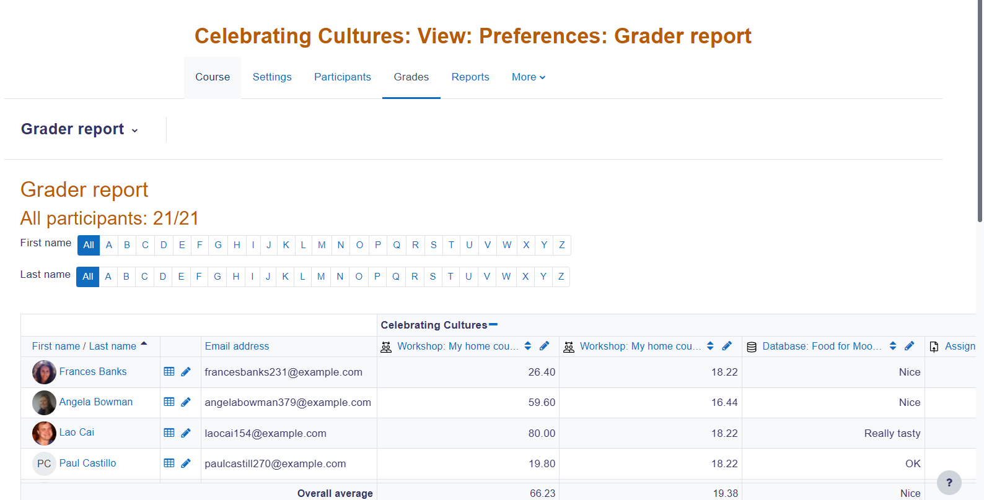

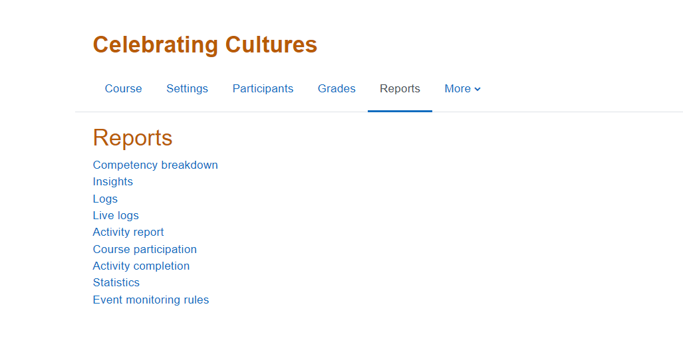

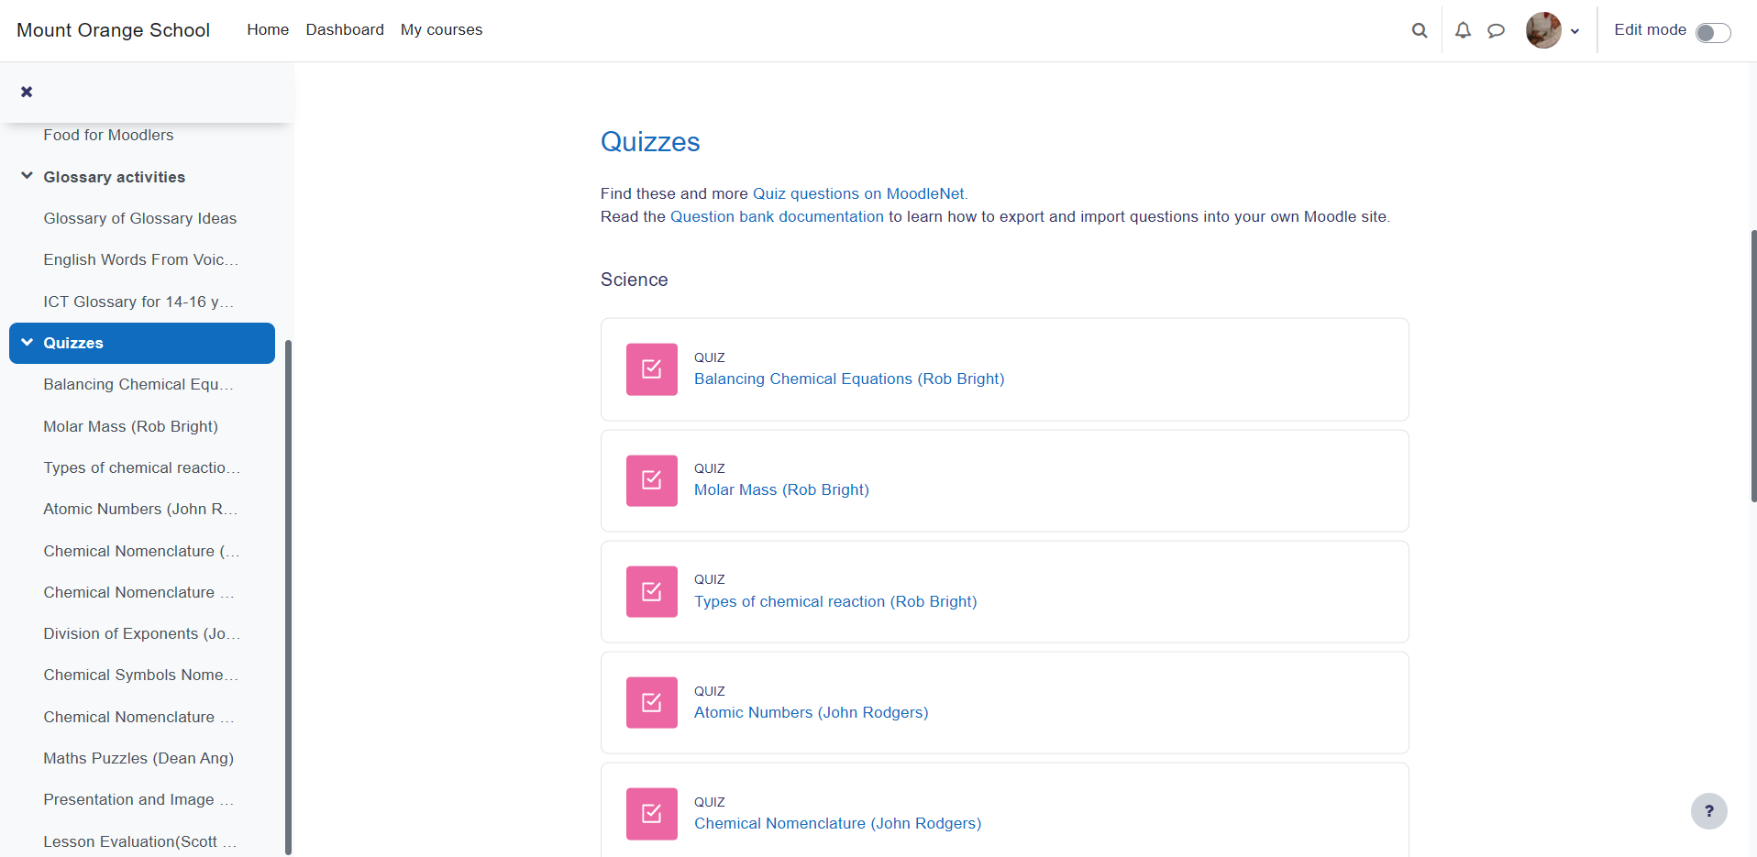 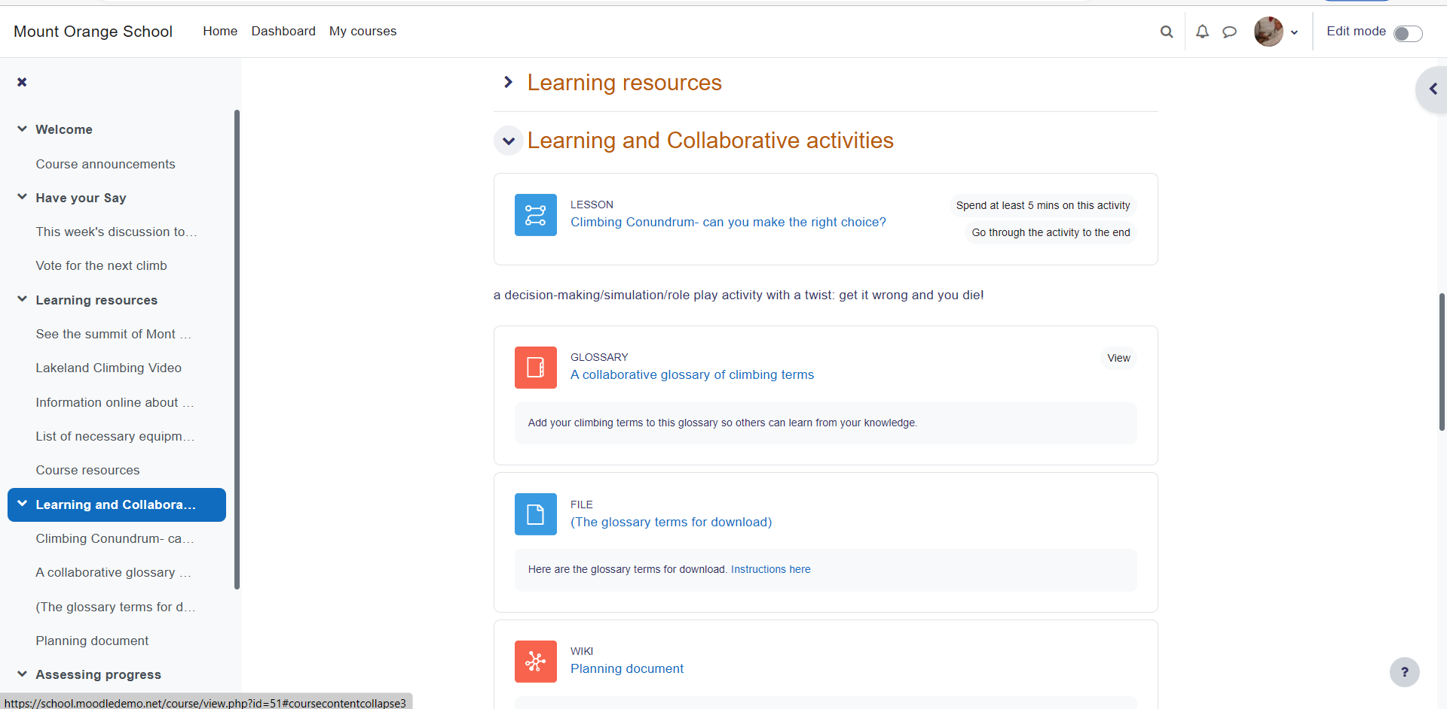

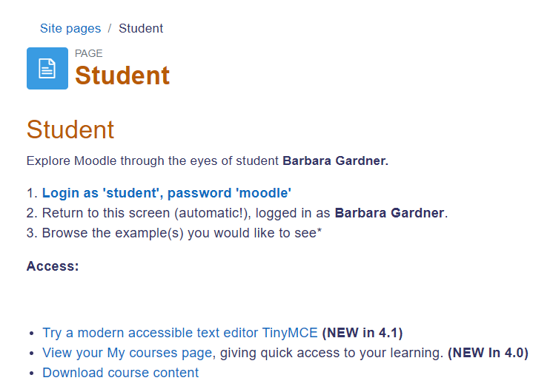

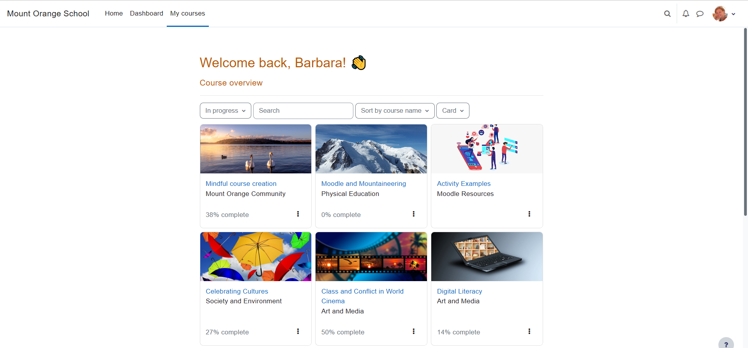

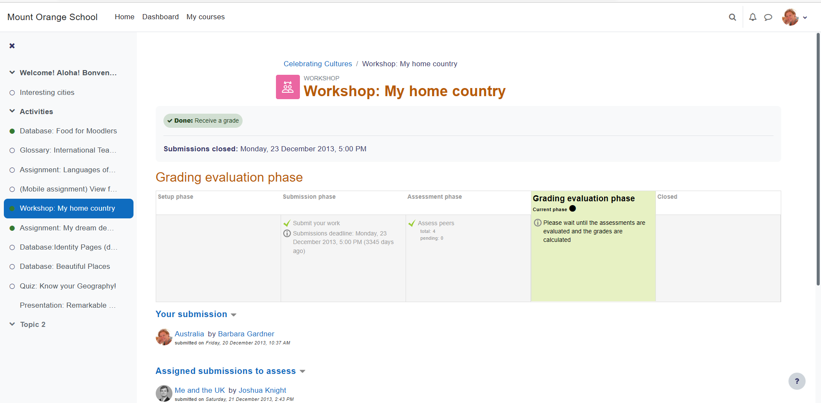



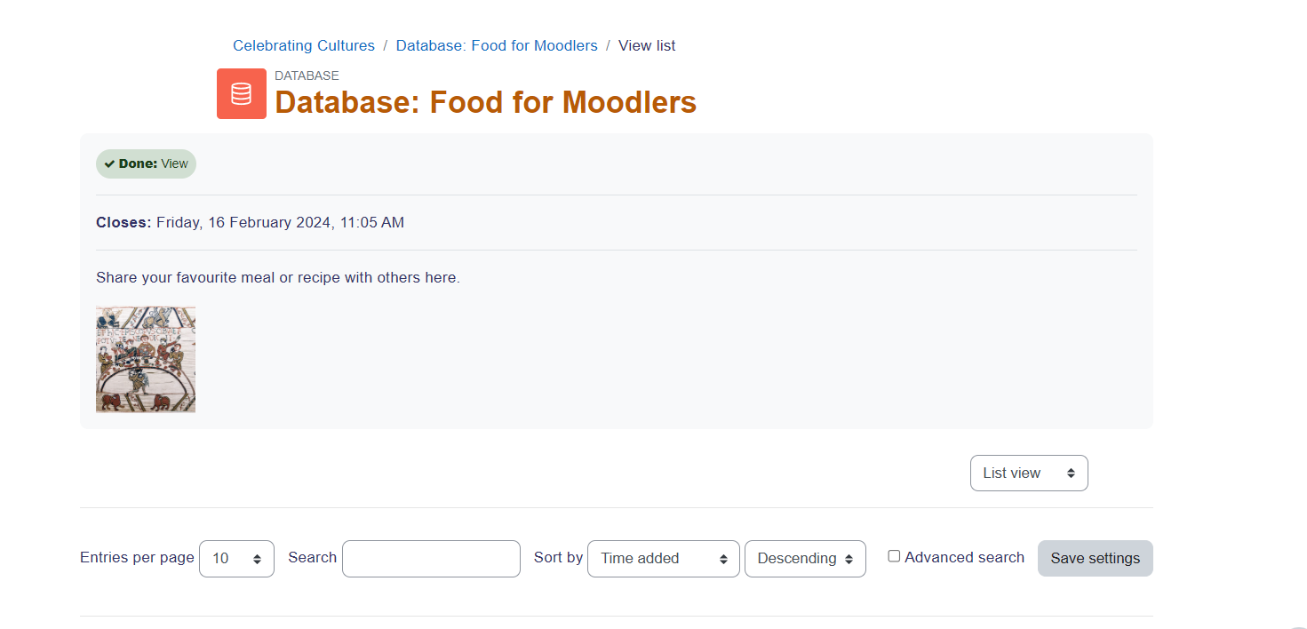

**5. Demonstrate FOSS software related to the database.**

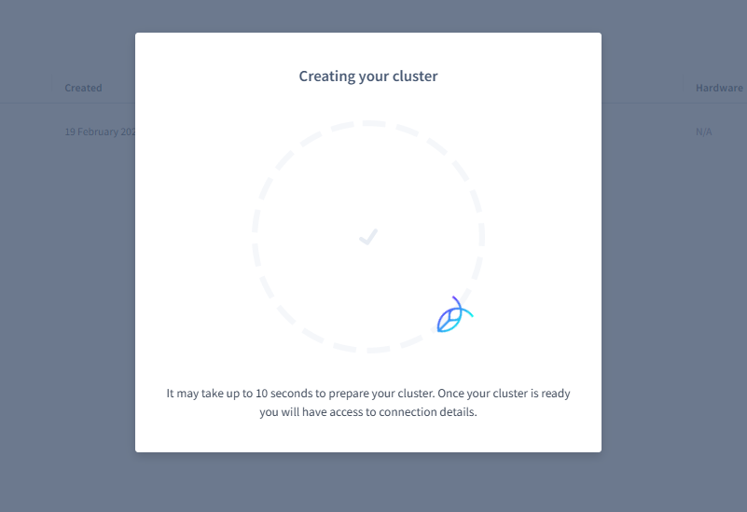

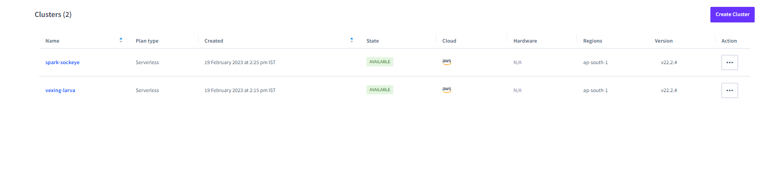

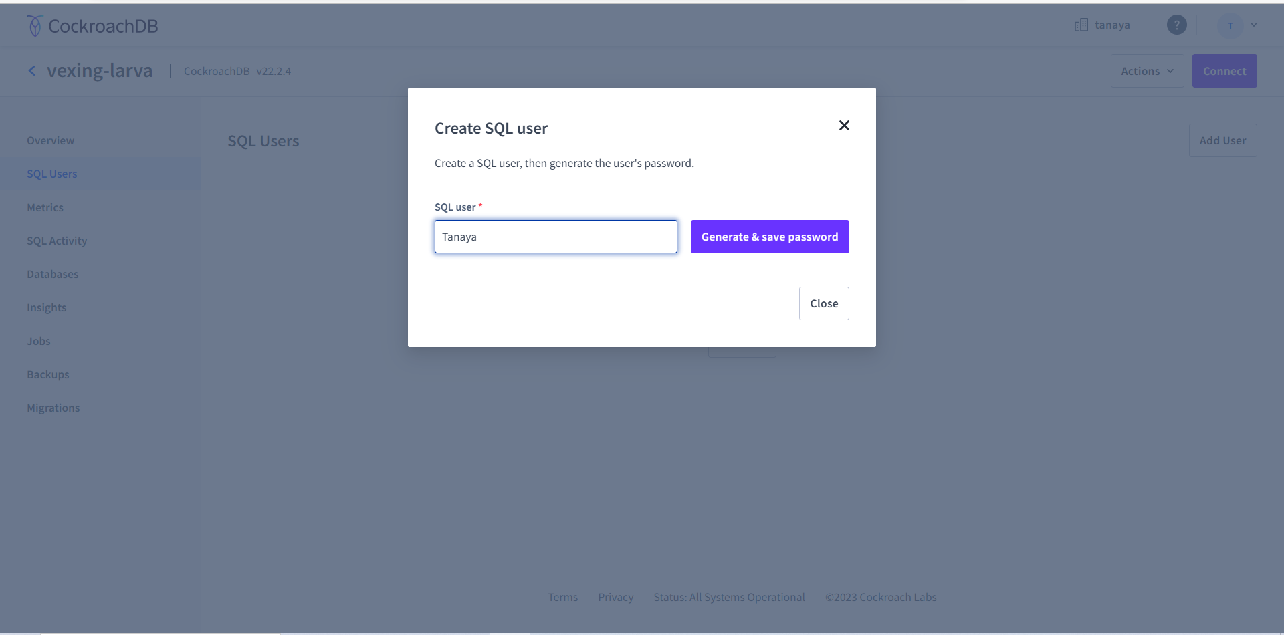

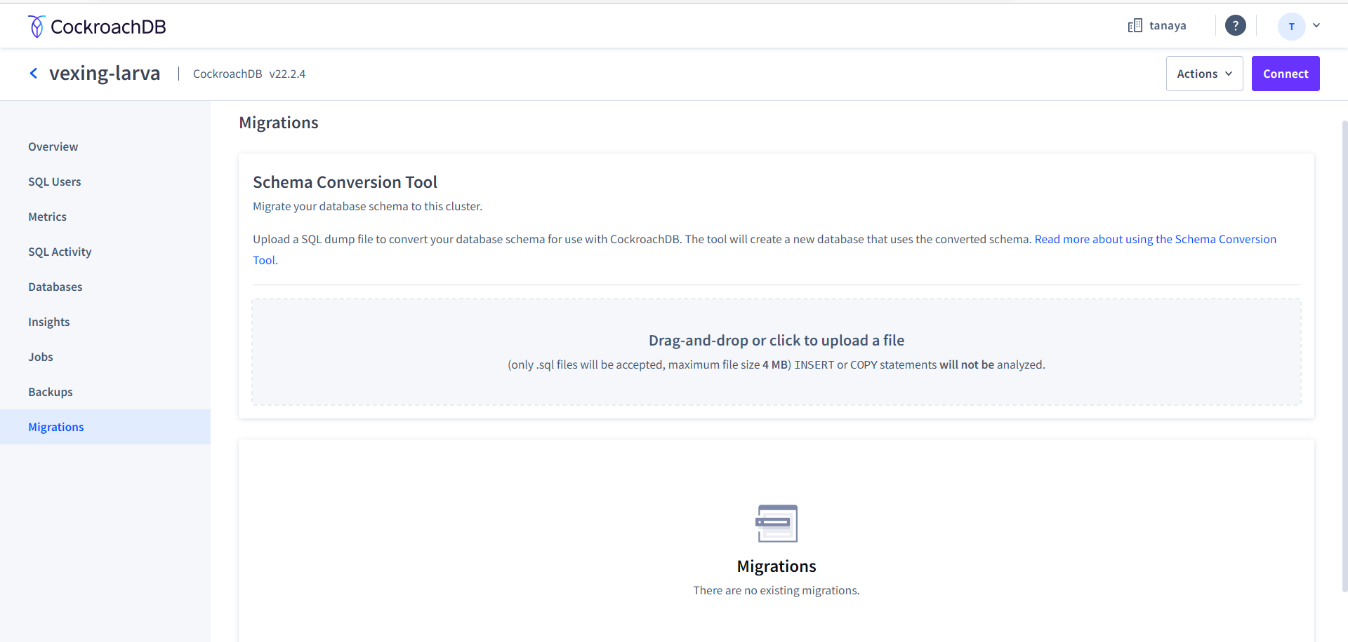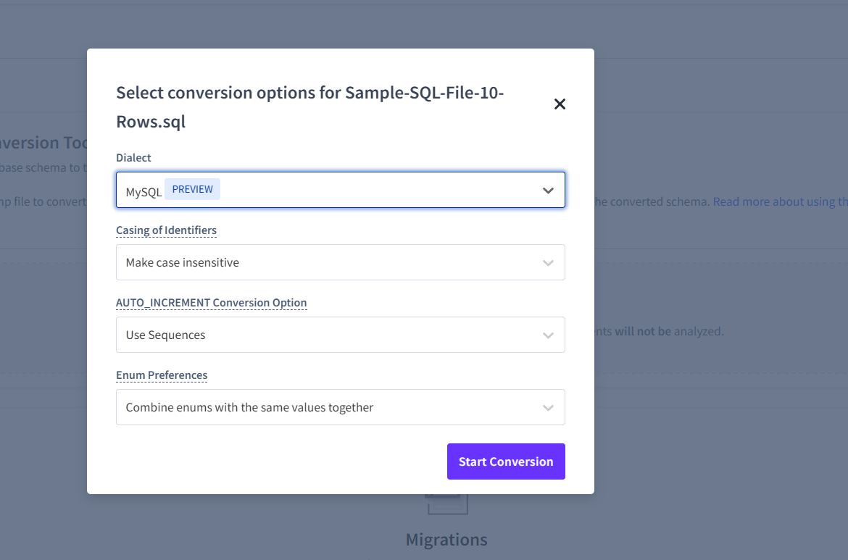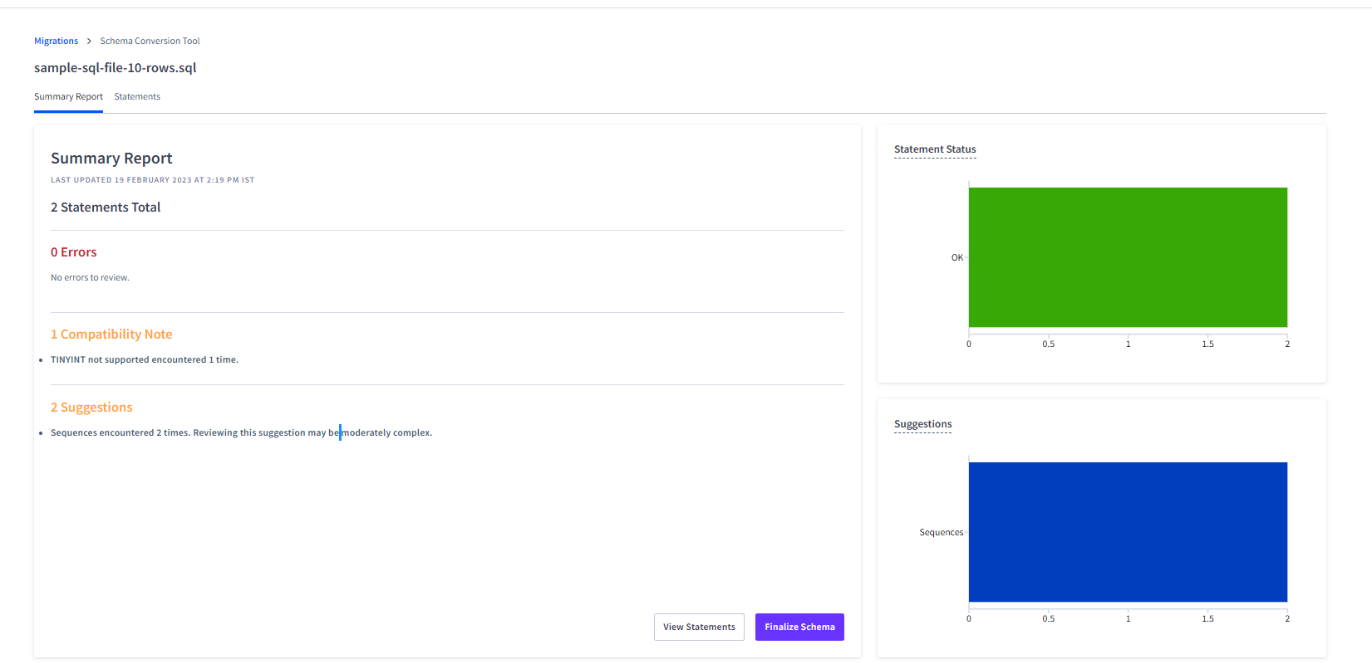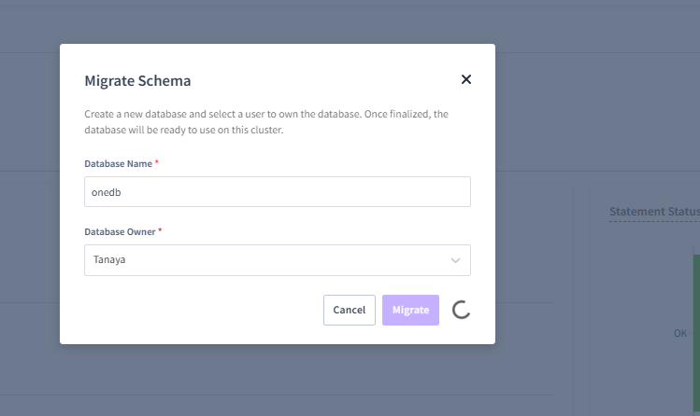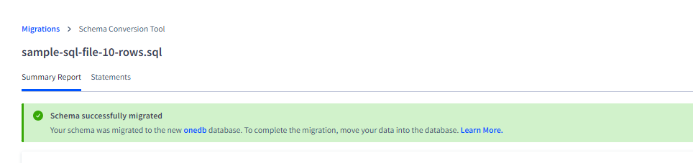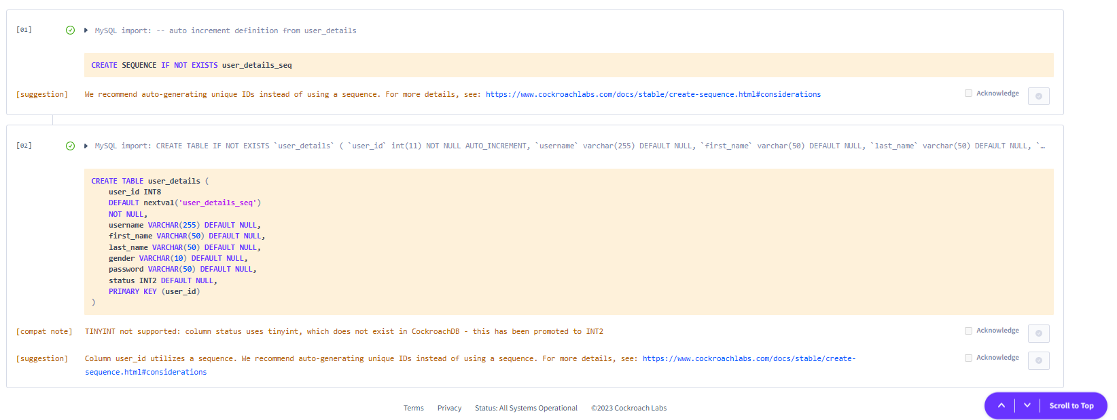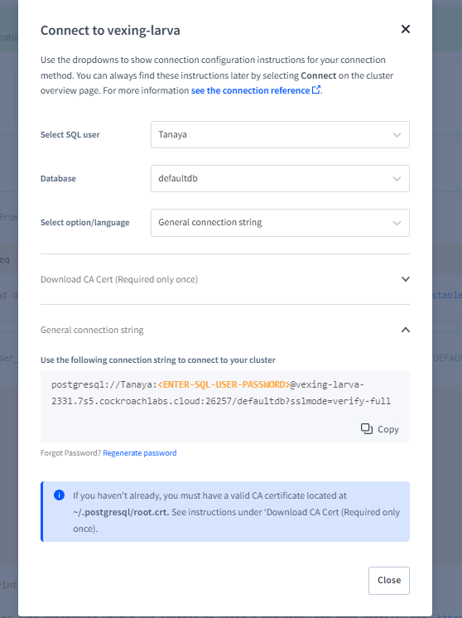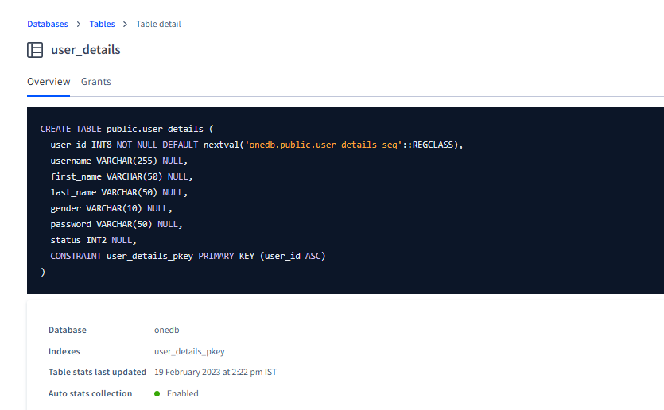

**6. How does the Exam software work?**

Exam software works by leveraging technology to automate the process of creating, administering, and grading exams. Here is a general overview of how it works technically:

Exam creation: The exam software provides a user interface for instructors to create exam questions, which can include multiple choice, short answer, essay, and other question types. The software stores the questions in a database and allows the instructor to organize them into exams.

Exam delivery: The exam software provides a platform for delivering exams to students. This can be done through a web interface or a standalone application. The exam software ensures that only authorized students can access the exam and that the exam is delivered securely.

Exam grading: The exam software provides a way to grade exams automatically. For multiple-choice questions, the software can match student responses against the correct answer key. For short answer and essay questions, the software can use natural language processing algorithms to grade the responses. Alternatively, the software can allow instructors to manually grade the exams.

Reporting: The exam software generates reports that show the results of the exams, including individual student scores and overall class performance. These reports can be used by instructors to identify areas where students need more help and to improve future exams.

To make all of this happen, the exam software typically relies on a variety of technologies, including databases for storing exam questions and student responses, web servers for delivering exams, and machine learning algorithms for grading responses. The software must also ensure the security and privacy of student data, which requires implementing strong encryption and access controls.